**Binary Tree-**

|  |
| --- |
| Binary tree is a special tree data structure in which each node can have at most 2 children.  Thus, in a binary tree,  Each node has either 0 child or 1 child or 2 children. |

**Example-**

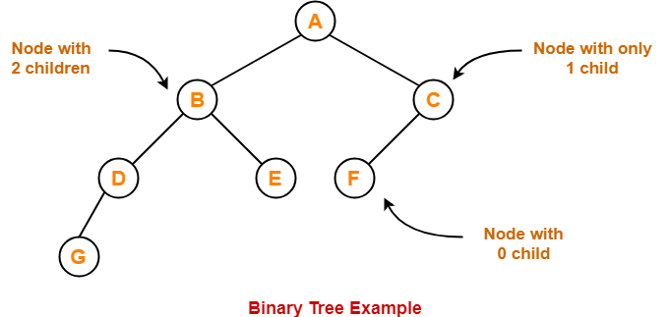

**Unlabeled Binary Tree-**

|  |
| --- |
| A binary tree is unlabeled if its nodes are not assigned any label. |

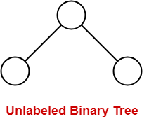

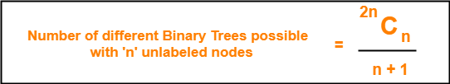

**Example-**

Consider we want to draw all the binary trees possible with 3 unlabeled nodes.

Using the above formula, we have-

Number of binary trees possible with 3 unlabeled nodes

= 2 x 3C3 / (3 + 1)

= 6C3 / 4

= 5

Thus,

* With 3 unlabeled nodes, 5 unlabeled binary trees are possible.
* These unlabeled binary trees are as follows-

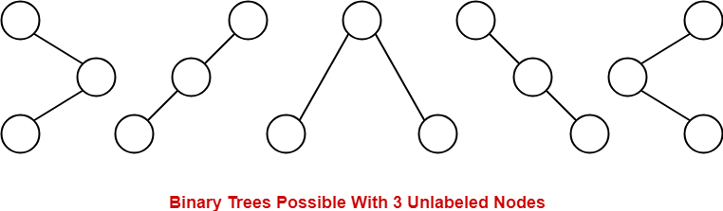

**Labeled Binary Tree-**

|  |
| --- |
| A binary tree is labeled if all its nodes are assigned a label. |

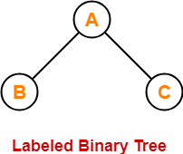

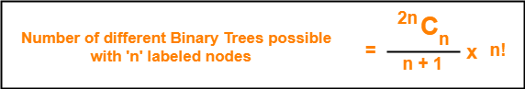

**Example-**

Consider we want to draw all the binary trees possible with 3 labeled nodes.

Using the above formula, we have-

Number of binary trees possible with 3 labeled nodes

= { 2 x 3C3 / (3 + 1) } x 3!

= { 6C3 / 4 } x 6

= 5 x 6

= 30

Thus,

* With 3 labeled nodes, 30 labeled binary trees are possible.
* Each unlabeled structure gives rise to 3! = 6 different labeled structures.

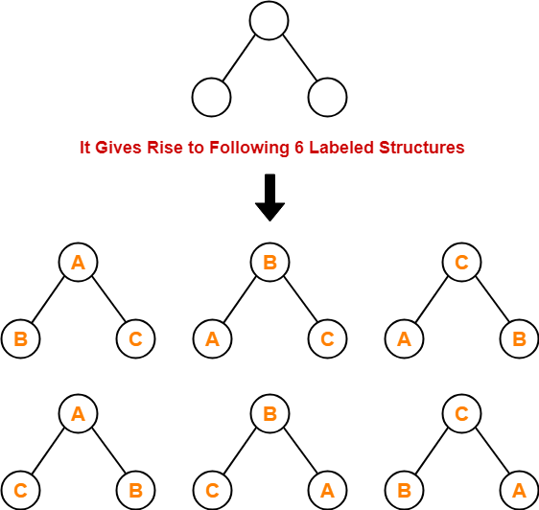

Similarly,

* Every other unlabeled structure gives rise to 6 different labeled structures.
* Thus, in total 30 different labeled binary trees are possible.

**Types of Binary Trees-**

Binary trees can be of the following types-

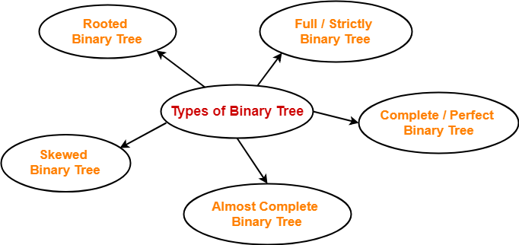

1. Rooted Binary Tree
2. Full / Strictly Binary Tree
3. Complete / Perfect Binary Tree
4. Almost Complete Binary Tree
5. Skewed Binary Tree

**1. Rooted Binary Tree-**

A **rooted binary tree** is a binary tree that satisfies the following 2 properties-

* It has a root node.
* Each node has at most 2 children.

**Example-**

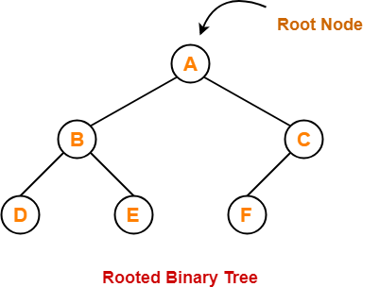

**2. Full / Strictly Binary Tree-**

* A binary tree in which every node has either 0 or 2 children is called as a **Full binary tree**.
* Full binary tree is also called as **Strictly binary tree**.

**Example-**

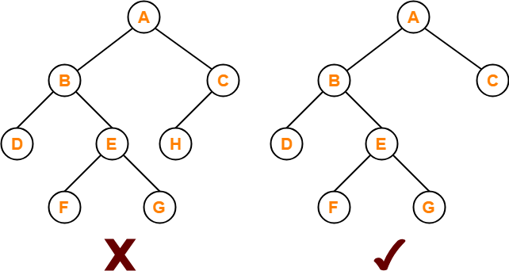

Here,

* First binary tree is not a full binary tree.
* This is because node C has only 1 child.

**3. Complete / Perfect Binary Tree-**

A **complete binary tree** is a binary tree that satisfies the following 2 properties-

* Every internal node has exactly 2 children.
* All the leaf nodes are at the same level.

Complete binary tree is also called as **Perfect binary tree**.

**Example-**

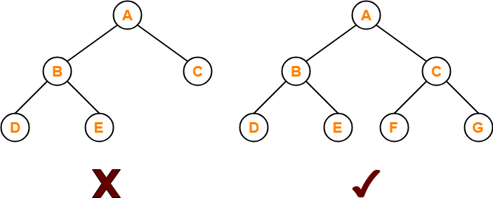

Here,

* First binary tree is not a complete binary tree.
* This is because all the leaf nodes are not at the same level.

**4. Almost Complete Binary Tree-**

An **almost complete binary tree** is a binary tree that satisfies the following 2 properties-

* All the levels are completely filled except possibly the last level.
* The last level must be strictly filled from left to right.

**Example-**

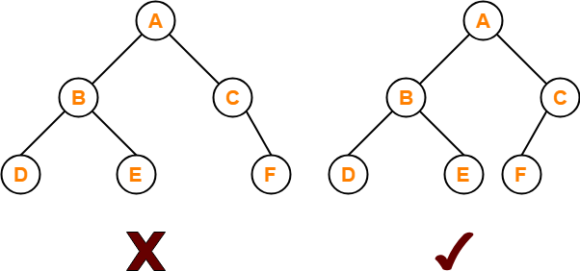

Here,

* First binary tree is not an almost complete binary tree.
* This is because the last level is not filled from left to right.

**5. Skewed Binary Tree-**

A **skewed binary tree** is a binary tree that satisfies the following 2 properties-

* All the nodes except one node has one and only one child.
* The remaining node has no child.

**OR**

A **skewed binary tree** is a binary tree of n nodes such that its depth is (n-1).

**Example-**

